Delta RMP Nutrient Symposium
Context for the Nutrients Symposium and Homework questions for RMP Steering Committee members
At the Delta RMP long-term planning meeting held on December 8, 2021, the Steering Committee discussed the overall strategy for long-term planning for Delta RMP projects and funding and decided to move forward with a long-term planning strategy. In FY22/23, the Delta RMP will be conducting long-term planning for nutrients which includes Harmful Algal Blooms (HABs). In Figure 3 the FY22/23 Workplan (see Figure 1 below) presents the general strategy for developing multi-year study designs. There are 5 elements to the strategy including identify the focus, determine what is known, identify the Delta RMP’s niche, identify funding and leveraging opportunities, and develop a multi-year study design. The Nutrient Symposium was designed to address two of these elements, determine what is known and identify funding and leveraging opportunities. The Nutrient Symposium will inform RMP participants about recent, current, and upcoming nutrient and HAB monitoring and research studies within the Delta. Information from the Nutrient Symposium will help the Steering Committee prioritize the management and assessment questions and to direct the Nutrient TAC to develop a 3–5-year study design. A deliverable from the Nutrient Symposium will be a report which summarizes the presentations from the Nutrient Symposium and captures the discussion and feedback from the Steering Committee members.
The Delta Science Program is convening a public workshop to facilitate discussions on collaborative efforts for harmful algal bloom (HAB) monitoring, data collection and sharing, and communication strategies for community safety. The agenda for the RMP Nutrient Symposium has been coordinated with the Delta Science Program to ensure the two are complimentary but not duplicative.
The Steering Committee will also need to revisit the management and assessment questions from the Delta Nutrient Research Plan (Table 13 below) when discussing long-term planning.
The Steering Committee members should consider the following questions while listening to the presentations during the Nutrient Symposium:
- What are the highest priority management and assessment questions your agency would like prioritized for nutrients and HABs?
- What are the data gaps that your agency/sector would like the DRMP to pursue or fill?
- What are the specific monitoring or special study recommendations you heard during the Nutrient Symposium that your agency would like included in the multi-year study design for nutrients and HABs?
- What are the topics or presentations for which your agency would like additional conversation/discussion in future DRMP meetings?
Figure 1 (Figure 3 in FY 22/23 Monitoring Workplan): General strategy for developing multi-year study designs as part of the Delta RMP long term planning strategy.
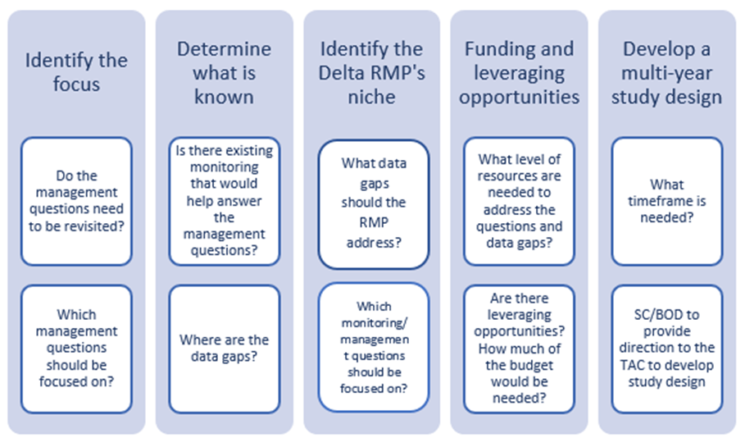

Management & Assessment Questions
As part of the long-term planning process, the Delta RMP in coordination with the Nutrient TAC will revisit the management and assessment questions (Table 13) to provide direction regarding the focus of monitoring for generally the next three to five years.
Table 13 from Delta Nutrient Research Plan. Delta RMP management and assessment questions for nutrients (revised May 30, 2018).
Type | Core Management Questions | Nutrients
Status & Trends | Is there a problem or are there signs of a problem?  Is water quality currently, or trending towards, adversely affecting beneficial uses of the Delta?  Which constituents may be impairing beneficial uses in subregions of the Delta?  Are trends similar or different across different subregions of the Delta? | How do concentrations of nutrients (and nutrient-associated parameters) vary spatially and temporally?  Are trends similar or different across subregions of the Delta?  How are ambient levels and trends affected by variability in climate, hydrology, and ecology?  Are there important data gaps associated with particular water bodies within the Delta subregions?
Sources, Pathways, Loadings & Processes | Which sources and processes are most important to understand and quantify?  Which sources, pathways, loadings, and processes (e.g., transformations, bioaccumulation) contribute most to identified problems?  What is the magnitude of each source and/or pathway (e.g., municipal wastewater, atmospheric deposition)?  What are the magnitudes of internal sources and/or pathways (e.g., benthic flux) and sinks in the Delta? | Which sources, pathways, and processes contribute most to observed levels of nutrients?  How have nutrient or nutrient-related source controls and water management actions changed ambient levels of nutrients and nutrient-associated parameters?  What are the loads from tributaries to the Delta?  What are the sources and loads of nutrients within the Delta?  What role do internal sources play in influencing observed nutrient levels?  What are the types and sources of nutrient sinks within the Delta?  What are the types and magnitudes of nutrient exports from the Delta to Suisun Bay and water intakes for the State and Federal Water Projects?  How are nutrients linked to water quality concerns such as harmful algal blooms, low dissolved oxygen, invasive aquatic macrophytes, low phytoplankton productivity, and drinking water issues?  Which factors in the Delta influence the effects of nutrients on the water quality concerns listed above?
Forecasting Scenarios | How do ambient water quality conditions respond to different management scenarios?  What constituent loads can the Delta assimilate without impairment of beneficial uses?  What is the likelihood that the Delta will be water quality-impaired in the future? | How will nutrient loads, concentrations, and water quality concerns from Sources, Pathways, Loadings & Processes Question 2 respond to potential or planned future source control actions, restoration projects, water resource management changes, and climate change?
Effectiveness Tracking | Are water quality conditions improving as a result of management actions such that beneficial uses will be met?  Are loadings changing as a result of management actions? | How did nutrient loads, concentrations, and water quality concerns from Sources, Pathways, Loadings & Processes Question 2 respond to source control actions, restoration projects, and water resource management changes?

